**Keep talking puzzles**

**Main concept**

There are several small control panels with puzzles in the server room. Instructions to the puzzles are in the lab room (picture on the wall). At least two people should play together. One is operator – person in front of the control panel and instruction guy, who will give hints according to the provided instructions in the lab room. Team should work together to find solutions.

1. **Maze**

Control panel contains an RGB LED matrix and 4 buttons. Task is to move green marker to the red position. The problem is – obstacles. Operator of the control panel can’t see the maze itself, but know the position of the markers. Maze is located in other room. Team should help operator to find a right way.

|  |  |  |  |  |  |  |  |  |
| --- | --- | --- | --- | --- | --- | --- | --- | --- |
|  | A | B | C | D | E | F | G | E |
| 1 |  |  |  |  |  |  |  |  |
| 2 |  |  |  |  |  |  |  |  |
| 3 |  |  |  |  |  |  |  |  |
| 4 |  |  |  |  |  |  |  |  |
| 5 |  |  |  |  |  |  |  |  |
| 6 |  |  |  |  |  |  |  |  |
| 7 |  |  |  |  |  |  |  |  |
| 8 |  |  |  |  |  |  |  |  |

Figure 1.1 What operator see on the matrix

|  |  |  |  |  |  |  |  |  |
| --- | --- | --- | --- | --- | --- | --- | --- | --- |
|  | A | B | C | D | E | F | G | E |
| 1 |  |  |  |  |  |  |  |  |
| 2 |  |  |  |  |  |  |  |  |
| 3 |  |  |  |  |  |  |  |  |
| 4 |  |  |  |  |  |  |  |  |
| 5 |  |  |  |  |  |  |  |  |
| 6 |  |  |  |  |  |  |  |  |
| 7 |  |  |  |  |  |  |  |  |
| 8 |  |  |  |  |  |  |  |  |

Figure 1.2 What painted on the wall

If operator made a mistake, puzzle will reset and positions of the markers will change.

1. **Morse**

Control panel contain LED, buzzer and several buttons of different colours. LED and buzzer transfers some sequence which represents a word (colour or other word which corresponds to this colour) in Morse codes. Goal of the operator is to determine a word and press corresponding button on the panel which corresponds to the named colour. If operator makes a mistake, than colour changes.

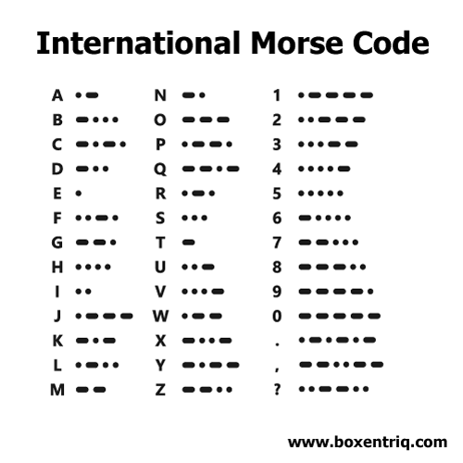

Figure 2.1 Morse code

1. **Simon says**

The operator should repeat sequence of colours by pressing corresponding buttons. But it is a bit harder than you expect. Colours are shifted.

So is sequence is Red -> White -> Pink -> Green, operator should press Yellow -> Green -> White -> Pink buttons.

|  |  |  |  |  |  |
| --- | --- | --- | --- | --- | --- |
| Red | Green | Blue | Yellow | Pink | White |
| Yellow | Pink | Red | Blue | White | Green |